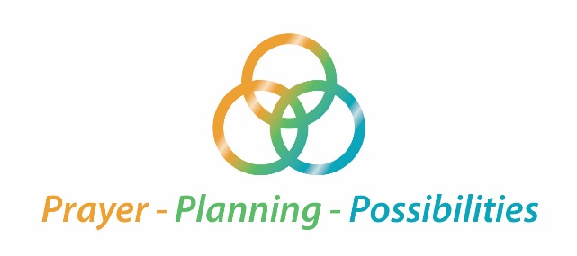

Key terms for parish restructuring

Types of parishes
Stand-alone parish:
One parish with one pastor, its own parish church, finances and finance council, parish council staff and office.
Partnered parish:
Two or more parishes that share one pastor as well as other resources, but they continue to exist as distinct parishes. They function in many ways like sister parishes. While they have their own parishioners, parish church and finances, they share the same pastor, staff and parish office.

Merged parish:
One or more parishes are absorbed into a stand-alone parish resulting, in the end, in one larger parish which includes all of the people, churches, property, assets, etc. of the original parishes. Merged parish is a transitional stage to becoming one, larger, stand-alone or partnered parish.

Please see reverse side
Types of churches
Parish church:
The primary church building in a parish (usually, but not always, sharing the same name as the parish) which provides the “full care of souls” — that is: Masses on Sundays, holy days of obligation, some weekdays — and reserves the Blessed Sacrament, provides baptism, confession, etc.

Secondary church :
Any church belonging to a parish, other than the parish church itself. When two or more parishes are merged together, each of which had its own church, the new parish will find itself the owner of multiple churches. One must be designated as the parish church, and the others are called secondary churches.
By law, the Eucharist must be reserved in every parish church, and for that reason, every parish church must be open to the faithful for at least some hours every day. There is no obligation to reserve the Eucharist in secondary churches, and without the Blessed Sacrament in the tabernacle, there is no obligation that the secondary church be opened every day.
Secondary churches do not have regular Sunday Masses, but are available at appropriate times for private prayer, devotions, weddings, funerals, festivals, etc. Mass is always celebrated at a secondary church on the feast day for which it is named.

Secondary mission church:
In the Diocese of Erie, secondary churches with permission for Sunday and holy day Masses are called mission churches.

